1. Locate the Control Panel folder.
   1. R:\storage\libarchive\b\1. Processing\8. Other Projects\Control Panel

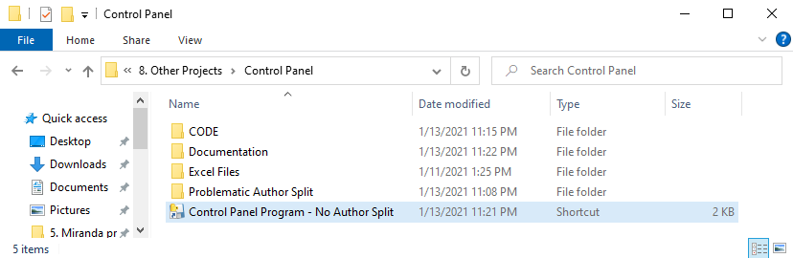

1. Open the program by double clicking the **“Control Panel Program”** shortcut.
   1. This may take 5 seconds or so, the executable isn’t very fast.
   2. NOTE: Currently the **author split program is not working** with the shortcut. This program will need to be ran separately.



1. The program should open and look like the following.

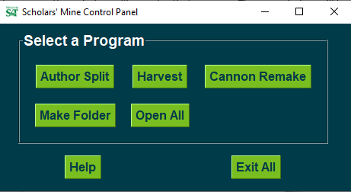

1. Select the program you wish to run; another window will open for that program. The new window will have a help button if you need additional help with the specific program.



1. You can also access this document by pressing the **“Help”** button while running the control panel program.



1. The **“Exit All”** button will close out of the control panel and any other additional programs that were opened using the control panel.

